*** Data Dispersion Methods: Understanding, Formulae, and Drawbacks***

**1) Range:**

- The range is the simplest measure of dispersion, representing the difference between the maximum and minimum values in a data set. It gives a quick sense of the spread of the data.

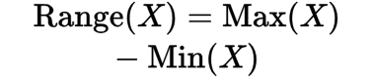

Drawbacks:

Sensitive to Outliers: The range is highly influenced by extreme values or outliers, which can give a misleading sense of dispersion if the data set has outliers.

Ignores Distribution: It only considers the two extreme values and ignores the distribution of the rest of the data points.

**2) Mean Deviation:**

- Mean deviation, also known as the average deviation, measures the average distance of each data point from the mean of the data set. It gives a better idea of dispersion by considering all data points.

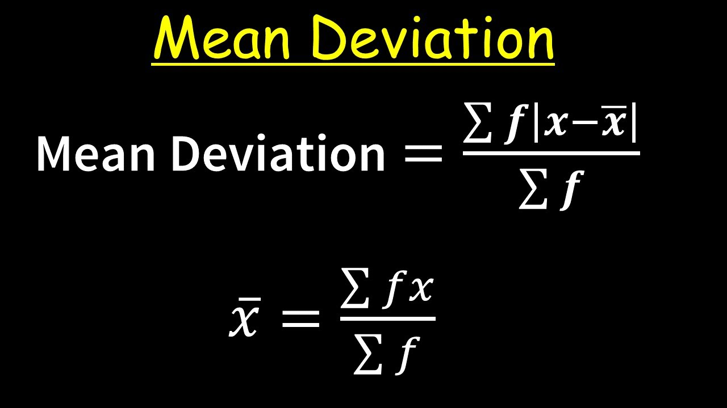

Drawbacks:

- Complexity: Calculating mean deviation involves finding the mean first and then computing the absolute deviations, which can be cumbersome for large data sets.

- Less Common: It's less commonly used in statistical analysis compared to variance and standard deviation.

**3) Absolute Mean Deviation:**

- Absolute mean deviation is similar to mean deviation but considers the absolute value of deviations from a central point, which could be the mean, median, or mode. It’s a measure of the average distance between each data point and a central point.

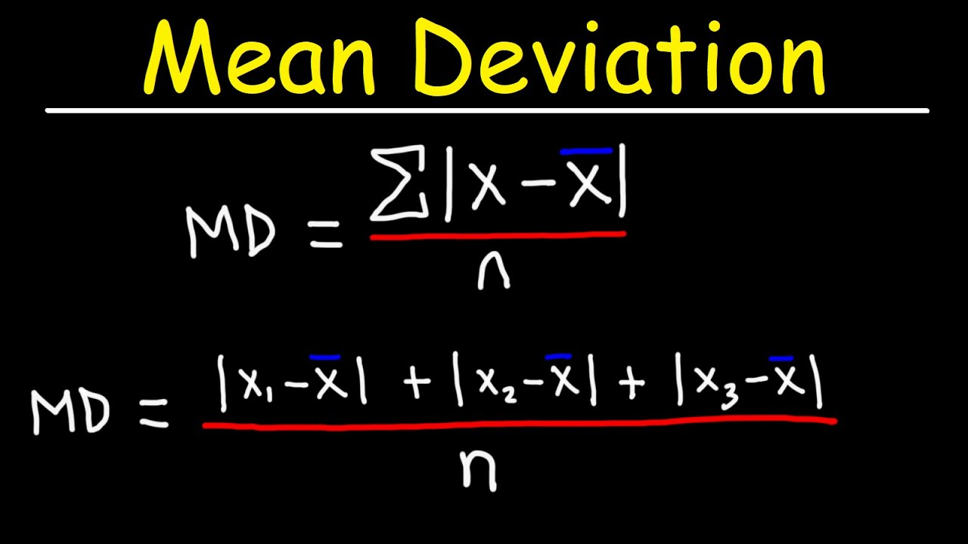

Drawbacks:

Choice of Central Point: The result can vary depending on whether the mean, median, or mode is chosen as the central point, leading to inconsistencies.

Not Widely Used: Like mean deviation, absolute mean deviation is not as commonly used in practice compared to variance or standard deviation.

**4) Variance:**

- Variance measures the average squared deviation from the mean, providing a sense of how much the data points differ from the mean. It’s a key concept in statistics and is widely used in fields like finance and economics.

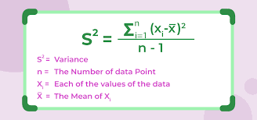

Drawbacks:

- Units: Since variance involves squaring the deviations, its unit is the square of the original data’s unit, which can be unintuitive and difficult to interpret.

- Sensitive to Outliers: Like range, variance can be sensitive to outliers, which can disproportionately affect the result.

**5) Standard Deviation:**

- Standard deviation is the square root of variance, bringing the measure of dispersion back to the original unit of the data. It is widely used to understand the spread of data around the mean.

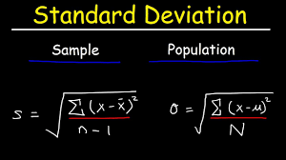

Drawbacks:

- Sensitive to Outliers: Standard deviation, like variance, is sensitive to outliers, which can lead to misleading results if the data set has extreme values.

-Assumes Normal Distribution: It is most effective for data sets that follow a normal distribution. For skewed distributions, other measures might be more appropriate.

### Summary:

Each of these measures of dispersion has its use cases, with range being the simplest but most limited, and standard deviation being the most widely used despite its sensitivity to outliers. The choice of method depends on the specific characteristics of the data and the requirements of the analysis.